1. Create parts table

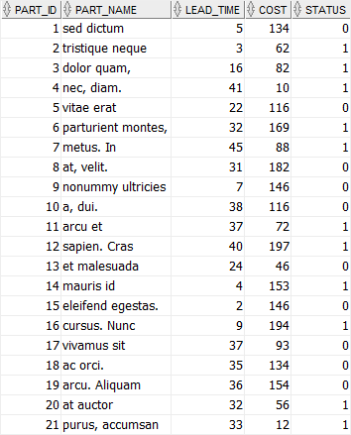

1. Change the cost of the part with id 1 to 130. Display the changes
2. Change the lead time, cost, and status of the part whose id is 5.

lead_time = 30, cost = 120, status = 1

1. Write an SQL statement that increases the costs of all parts in the parts table 5%:
2. Delete record with id 1
3. Create persons table.  persons table has three columns: person_id, first_name, and last_name.
4. To the created table, add birthdate column ,set its constraint to NOT NULL
5. Add two more columns to this table, phone and email
6. Write SQL statements to change the birthdate column to a null-able column.
7. Write SQL statements to change phone and email to a null-able column.
8. Remove the phone and email columns from the persons table:
9. Rename the first_name column to forename column:
10. Rename the persons table to people table
11. Create suppliers table

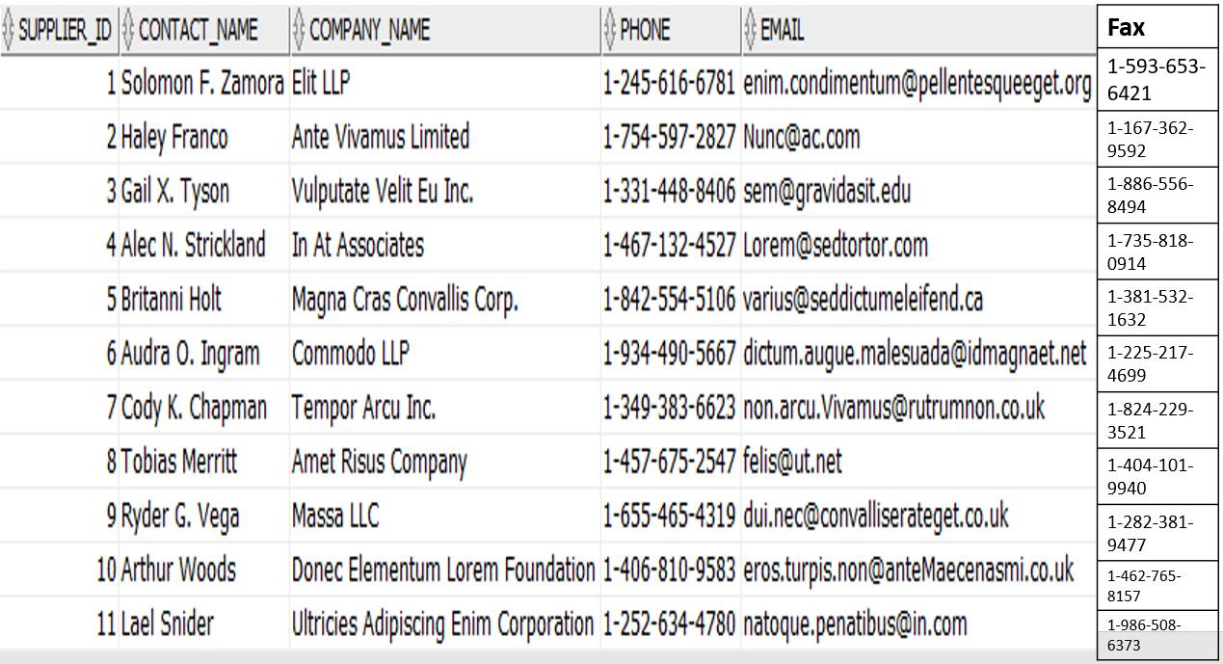

1. Set fax as the unused column
2. Drop the all unused columns from the suppliers table
3. Delete the table
4. What if we have cascading tables?-Lecturer demonstration
5. TRUNCATE AND RENAME-Lecturer demonstration
6. DELETE VS DROP VS TRUNCATE-?-Lecturer demonstration
7. Create employee table

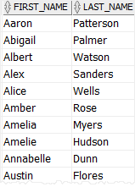

1. Create column alias, forename for first_name, surname for last_name . Display the results with forenames listed in ascending order.
2. Use column alias for an expression, concatenate the first name, space, and the last name to construct the full name.
3. Create orders table

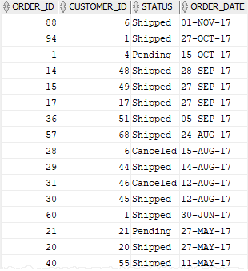

1. Write SQL statement that retrieves the orders that meet all the following conditions:

* placed in 2017
* is in charge of the customer id 44
* has the shipped status.

1. Sort the rows as per descending order of order_id
2. Create table emp

EMP_NO EMP_NAME JOB_NAME MGR_ID DEPT_NO

---------- -------------------- ---------- ---------- ----------

1234 Alex Clerk 4567 15

2345 Jack Consultant 3456 25

3456 Paul Manager 1234 15

4567 Jenefer Engineer 2345 45

1. Create table dep

DEPT_NO DEP_NAME LOCATION

---------- ---------- ----------

15 FINANCE PARIS

25 MARKETING LONDON

35 HR DELHI

1. Retrieve all orders and employees data from both orders and employees tables(left join)
2. Retrieve all salesman and their sales orders if any(right join)-(Lecturer demonstration)
3. Find the jobs of employees whose names start with 'A'
4. From parts table, display the parts where costs are between 50 and 100